**Sample Conversation Log**

This document is going to looking at and going over some chat logs from my ChatBot to show off the features and functionality I have created for submission 1 of artificial intelligence.

**DrawAnimal**

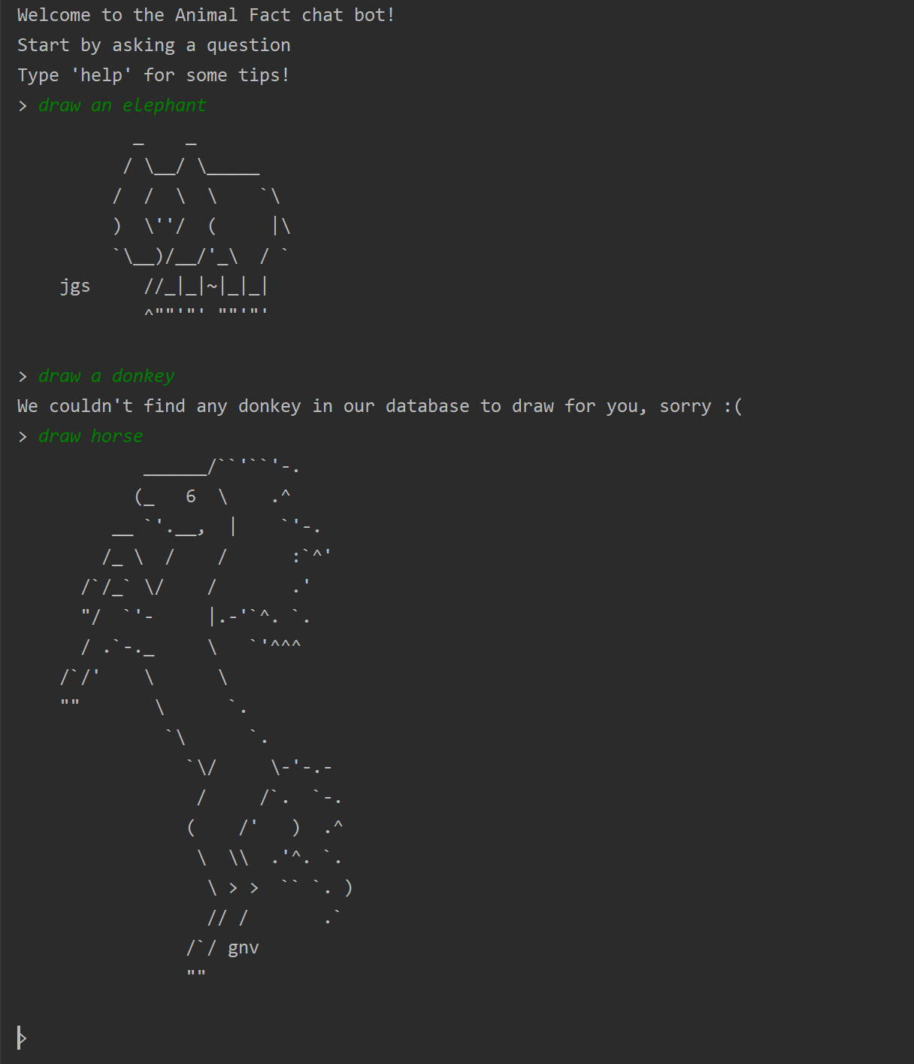One of the features of the chatbot is that it will draw an ASCII image based off an online library. There is a function that has a set number of animals that it can draw, it then grabs the ASCII image from a web page and prints that into the chat.

**Wikipedia API**

The program also has some Wikipedia API built into it, the trigger words for the API are questions such as:

‘What is *a’, ‘What is an *’ ‘Define *’

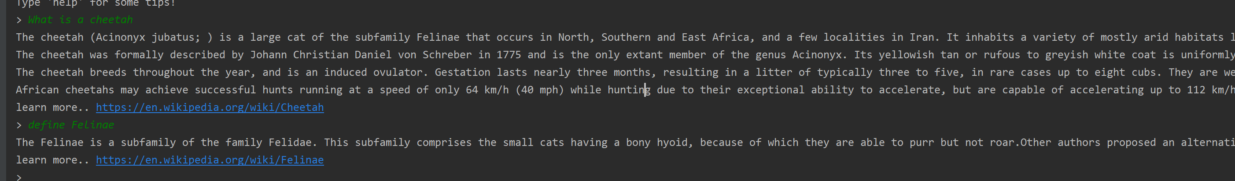If one of these trigger words are typed Wikipedia will be searched to see if a page exists based on the user input, if

**Rule-based and similarity-based component**

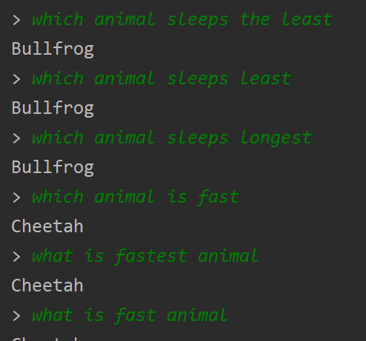The rule-based and similarity-based component has pre-set list of questions contained in a .csv file called AI.csv, the file contains about 30 pre set questions such as “Which animal sleeps the least”, “Which animal is the fastest?”.

When the user inputs, if it is in one if the aiml trigger words for the similarity-based component and not for the Wikipedia search the program will match the user input to the closest rule-based pre-set question from the .csv file. This means a user can have a typing error and the answer will still be shown correctly.